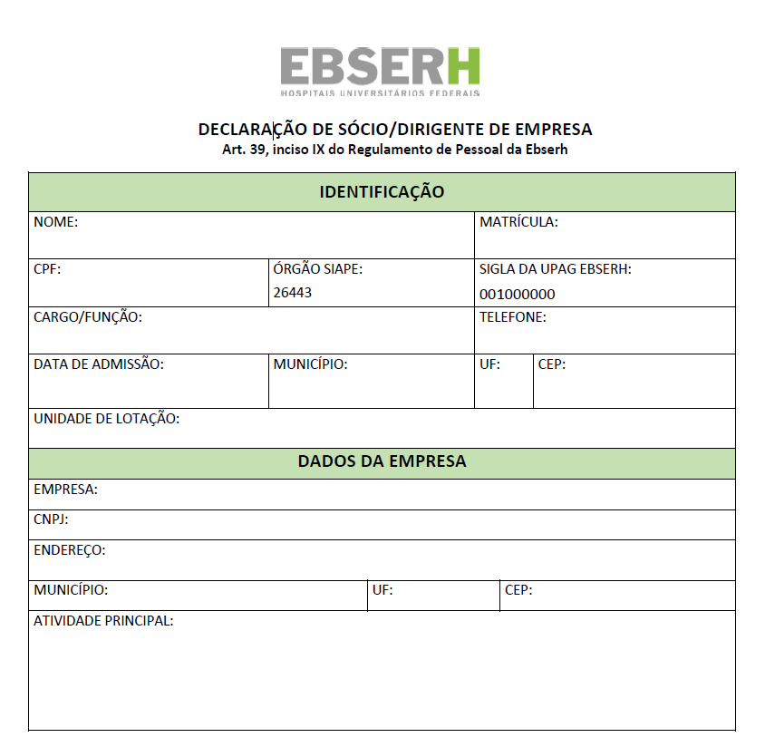

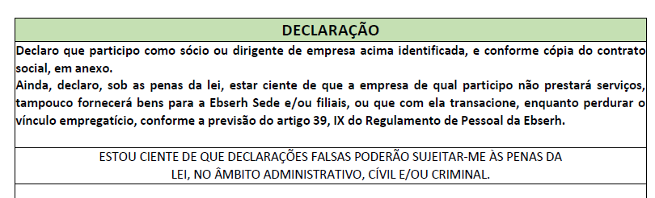

Rio de Janeiro, ______ de ______________________ de ___________.

______________________________________________________________________

Assinatura