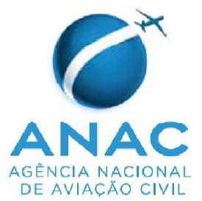 | Superintendência de Padrões Operacionais – SPO  Canadian Maintenance Organization (AMO) application for initial /amendment of a Brazilian Maintenance Organization Approval in accordance with the Technical Arrangement on Maintenance – TA-M between TCCA and ANAC.
For the applicant:
- TCCA AMO name:

- TCCA CAR 573 AMO number:

- Address of AMO (principal address):

- Mailing Address (if different from 3 above):

- Tel:

- Main and secondary Contact E-mails:

- AMO Ratings (according to the TCCA system):
- Please select the type of application and complete the section 8 of this form.
a. Initial
b. Amendment:
b.1. Changes of Address
b.2. Change of Accountable manager
b.3. Change of organization name

(in case of amendment) ANAC RBAC 145 certificate approval number:
- Application:

I wish to apply on behalf of this Canadian AMO in accordance with item 8 to maintain or alter aeronautical products registered or operated under the provisions of Brazilian Regulations RBAC in accordance with the MoU and TA-M concluded between the ANAC and TCCA.

I am aware that to be approved under the terms of the TA-M, the AMO must:
- Be located in Canada
- Hold a valid TCCA CAR 573 approval
- Establish an ANAC Supplement to the MPM in accordance with the guidance material (TA-M section C)

Date (Month/Day/Year):

Name & Signature of the AMO Accountable Executive:

Note: This application form shall be addressed to TCCA office, responsible for the surveillance of your organization, together with documents supporting the application. The applicant shall not send this form to ANAC - Brazil.
For TCCA Inspector
- Please process this application in accordance with TCCA internal procedures.

